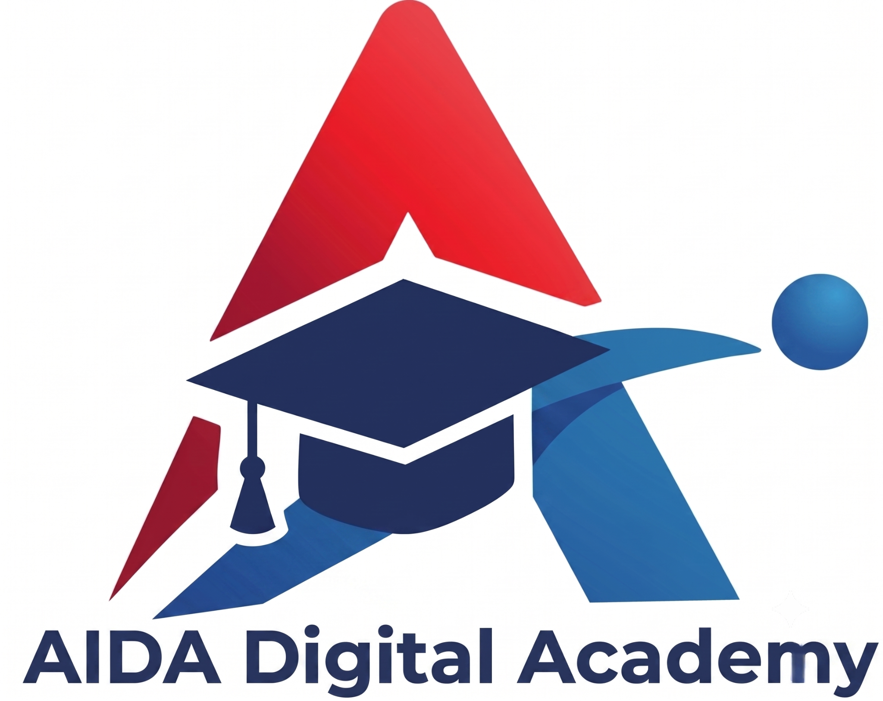
AI LEADER
Leading AI-enabled Enterprise using ChatGPT Ecosystem
PROGRAM CURRICULUM
8 courses | 16 workshops x 2 hours | 32 hours total
A leadership pathway from ChatGPT fluency and structured interaction to enterprise design, functional transformation, governance and workforce adoption.
PURPOSE
To prepare leaders to turn ChatGPT capabilities into measurable, governed enterprise outcomes - aligning strategy, product, marketing, operations, finance and talent while preserving human accountability.
Prepared for website publication by AIDA Digital Academy

AI LEADER
Program Overview

AI Leader: Leading AI-enabled Enterprise using ChatGPT Ecosystem is a management development program for executives, business leaders and functional managers who must turn generative AI capability into measurable enterprise value. It moves beyond personal productivity to the leadership work of setting direction, choosing high-value applications, redesigning products and operating processes, building governance, developing people and maintaining accountability. Participants learn to use ChatGPT as a research, analysis, design and execution partner while preserving the authority of human leaders over consequential decisions.
The journey begins with the ChatGPT ecosystem and advanced prompt engineering, then develops an enterprise AI blueprint and an AI product management discipline. It applies those foundations to digital marketing, operations, finance and talent management, using authentic management artifacts such as decision memos, product requirements, campaign systems, operating workflows, forecasts and workforce plans. Each course is delivered in two focused two-hour workshops: the first establishes the leadership framework and guided practice; the second integrates the method into a governed, reviewable deliverable that can be adapted to the participant's organization.
NAVIGATE | STRUCTURE | DESIGN | PRODUCTIZE | MARKET | OPERATE | STEER | ENABLE
What participants should be able to do
Select the right ChatGPT surface, model, tool, app and workspace pattern for a leadership outcome.
Structure interactions with clear objectives, context, trusted sources, constraints, output schemas and verification criteria.
Design an AI-enabled operating model that aligns strategy, data, governance, adoption and measurable value.
Lead AI product discovery, definition, prototyping, evaluation, launch and continuous improvement.
Direct AI-enabled marketing research, campaigns, content operations, personalization and measurement within brand controls.
Redesign operations with AI-assisted process analysis, standard work, automation, exception handling and metrics.
Use ChatGPT for governed planning, forecasting, scenario analysis, variance explanation and management reporting.
Apply AI to workforce planning, role design, recruitment support, onboarding, learning and development responsibly.
Program at a glance
# | Course | Delivery
1 | ChatGPT Ecosystem | 2 × 2 hrs
2 | Advanced Prompt Engineering | 2 × 2 hrs
3 | Designing an AI-enabled Enterprise | 2 × 2 hrs
4 | AI Product Management | 2 × 2 hrs
5 | AI-enabled Digital Marketing | 2 × 2 hrs
6 | AI-enabled Operations | 2 × 2 hrs
7 | AI-enabled Financial Management | 2 × 2 hrs
8 | AI-enabled Talent Management | 2 × 2 hrs

CURRICULUM
Courses 1-2

01 | ChatGPT Ecosystem  Understand the capabilities, work surfaces and controls leaders can mobilize.
This course gives leaders a current map of the ChatGPT ecosystem and a method for choosing the right capability for each outcome. Participants explore multimodal chat, voice, image generation, search and deep research, file and data analysis, Canvas, Projects, memory and Custom GPTs, subject to plan and workspace settings. They examine connected apps, plugins, reusable agents and ChatGPT Work for multi-step tasks, then distinguish when Codex or the OpenAI Platform is the right extension point. The course connects capability to enterprise controls: roles, permissions, source-system access, cost, privacy, retention, auditability and human approval.
Workshop structure and capabilities
• Workshop 1 - ChatGPT modes, multimodal work and research | • Workshop 2 - Projects, GPTs, apps, Work, Codex and Platform
• Models, tools, files, data analysis and reusable context | • Workspace permissions, privacy, retention and approval
Activation focus: Choose the smallest governed ChatGPT configuration that can deliver the intended business result.

02 | Structured Interaction with ChatGPT using Advanced Prompt Engineering  Turn executive intent into reliable, reviewable AI work.
This course teaches leaders to treat prompting as a work contract, not a clever phrase. Participants structure requests around the decision or deliverable, audience, context, approved sources, task, constraints, examples, output schema and quality rubric. They practice instruction hierarchy, separating source data from instructions, decomposing complex work, maintaining useful context and asking ChatGPT to expose assumptions, uncertainty and missing evidence. The second workshop builds reusable patterns for analysis, decision memos, executive communication and scenario planning. Participants test edge cases, conflicting instructions, prompt injection, unsupported claims and sensitive information, then establish a verify-revise-approve loop.
Workshop structure and capabilities
• Workshop 1 - Prompt contracts, context and output control | • Workshop 2 - Reusable patterns, testing and evaluation
• Sources, examples, schemas, rubrics and uncertainty | • Injection resistance, verification and approval loops
Activation focus: Create a reusable interaction pattern that produces consistent leadership-quality work.

CURRICULUM
Courses 3-4

03 | Designing an AI-enabled Enterprise  Align strategy, operating model, governance and adoption around value.
This course helps leaders design the enterprise around AI-enabled decisions and workflows rather than scattered pilots. Participants define an AI ambition and value thesis, identify value pools, and prioritize use cases by business impact, data readiness, feasibility, adoption effort and risk. They design the target operating model: executive sponsorship, product and process ownership, a federated or centralized enablement model, data and application boundaries, build-buy-partner choices, workforce capability and funding. Governance is operationalized through the NIST AI RMF functions - Govern, Map, Measure and Manage - alongside use-case intake, risk tiers, testing, access controls, human oversight and incident response. The second workshop converts the design into a phased roadmap with owners, adoption measures, benefit metrics and scale-or-stop gates.
Workshop structure and capabilities
• Workshop 1 - AI ambition, value pools and use-case portfolio | • Workshop 2 - Operating model, roadmap and adoption plan
• Data, architecture, ownership and build-buy-partner choices | • NIST-aligned governance, metrics and incident readiness
Activation focus: Produce an enterprise AI blueprint that connects strategic value to accountable execution.

04 | AI Product Management  Lead AI products from evidence-based discovery to measurable adoption.
This course adapts product management to AI systems whose outputs are probabilistic and context-dependent. Participants use ChatGPT to synthesize customer interviews, support tickets, market signals and product data; frame opportunities; define personas, jobs and outcomes; and draft a product strategy, value proposition and product requirements document. They design the AI experience across prompts, context, data, tools, user controls, transparency, escalation and human fallback, while comparing Custom GPT, app and API delivery options. The second workshop creates a prototype and evaluation plan with representative test cases, quality rubrics, safety checks, latency and cost targets, telemetry and adoption metrics. Participants finish with a staged launch decision, feedback loop and roadmap that balances desirability, viability, feasibility and responsible use.
Workshop structure and capabilities
• Workshop 1 - Discovery, strategy, PRD and AI experience | • Workshop 2 - Prototype, eval plan, launch and roadmap
• Customer evidence, prompts, context, tools and fallback | • Quality, safety, cost, latency, telemetry and adoption
Activation focus: Define an AI product whose value and behavior can be tested before it is scaled.

CURRICULUM
Courses 5-6

05 | AI-enabled Digital Marketing Management  Build a governed marketing system from insight to performance.
This course shows marketing leaders how to use ChatGPT across the full management cycle. Participants combine approved research and first-party context to analyze markets, competitors, customers and journeys; define segments and personas; identify value propositions; and create campaign briefs, channel strategies and editorial plans. They develop a reusable brand and evidence context for drafting web, email, social, advertising and sales-enablement assets, then use human review to protect accuracy, tone and intellectual property. The second workshop designs a campaign operating rhythm with variants, personalization rules, approval stages, content reuse and connected-app handoffs. Experiment design, attribution limits, leading and lagging indicators, privacy, disclosure and substantiation of AI-related claims ensure that speed does not outrun trust.
Workshop structure and capabilities
• Workshop 1 - Market insight, audience, journey and campaign | • Workshop 2 - Content operations, testing and optimization
• Brand context, channel variants and personalization rules | • Privacy, claims, approvals, attribution and performance
Activation focus: Create an AI-enabled campaign system that is fast, on-brand, evidence-based and measurable.

06 | AI-enabled Operations Management  Redesign workflows for speed, quality, resilience and control.
This course applies ChatGPT to the management system behind reliable operations. Participants map customer-to-customer processes, clarify demand and service levels, analyze bottlenecks and failure demand, and convert fragmented knowledge into standard operating procedures, decision guides and management dashboards. They distinguish AI assistance, deterministic automation and agentic workflows, selecting each according to process variability, consequence and required control. The second workshop redesigns one operational workflow with approved data and apps, defined inputs and outputs, exception paths, ownership, approvals, fallback procedures and evidence of completion. Learners use KPI and root-cause analysis, capacity and scenario planning, quality checks, change control, observability and continuous-improvement cycles to ensure automation strengthens rather than obscures accountability.
Workshop structure and capabilities
• Workshop 1 - Process mapping, SOPs, capacity and quality | • Workshop 2 - Workflow redesign, controls and KPI loop
• Copilot, deterministic automation and agent choices | • Exceptions, approvals, runbooks, audit and resilience
Activation focus: Redesign one critical workflow with measurable service, quality and control improvements.

CURRICULUM
Courses 7-8

07 | AI-enabled Financial Management  Accelerate insight while preserving evidence and financial control.
This course equips finance leaders to use ChatGPT as an analytical and communication layer over approved financial information. Participants structure data and assumptions, review spreadsheets, explain budget-to-actual variances, model cash flow and scenarios, identify forecast risks, and create source-backed management reporting. They separate factual records from assumptions, keep calculations inspectable, reconcile outputs to source data and document uncertainty. The second workshop builds a repeatable planning-to-reporting workflow with version control and review checkpoints. COSO-aligned principles frame access, segregation of duties, approval, evidence, audit trails and monitoring; transactions and accounting judgments remain under qualified human authority.
Workshop structure and capabilities
• Workshop 1 - Forecasts, scenarios, variance and cash flow | • Workshop 2 - Management reporting and control workflow
• Spreadsheet review, assumptions and source-backed narrative | • COSO-aligned access, approval, evidence and auditability
Activation focus: Build a finance workflow that is faster to run and easier to review, reconcile and audit.

08 | AI-enabled Talent Management  Develop the workforce and leadership practices required for AI-enabled work.
This course helps leaders reshape talent systems for human-AI collaboration. Participants use ChatGPT to analyze future work, build role and skills taxonomies, redesign jobs and teams, create competency profiles, and identify learning priorities. They develop responsible support materials for job descriptions, structured interviews, onboarding, learning, manager coaching and performance development without delegating employment decisions to the model. The second workshop creates an adoption plan with role-based learning, communities of practice, leader routines and measures of proficiency and impact. Privacy, consent, accessibility, disability accommodation, bias testing, adverse-impact monitoring and documented human review remain design requirements.
Workshop structure and capabilities
• Workshop 1 - Workforce, roles, skills and talent workflows | • Workshop 2 - Learning, adoption and manager enablement
• Recruitment support, onboarding and development tools | • Privacy, accessibility, fairness and human decisions
Activation focus: Create a talent plan that equips people to lead and work responsibly in an AI-enabled enterprise.
Curriculum currency and availability
ChatGPT, OpenAI models and connected capabilities evolve rapidly. Product names, tools, apps, agents, plan requirements, regional availability and administrator settings may change. AIDA Digital Academy should confirm live workspace capabilities, organizational policies, approved data sources and exercises before each delivery while preserving these learning outcomes.

